# Location and how to get to CMI

Address: Czech Metrology Institute, Hvožďanská 2053/3, 148 00 Prague

GPS: N 50°2.25657', E 14°29.16790'

To get information about Prague public transport, use [Googlemaps](https://www.google.com/maps) or <https://www.dpp.cz/en>

**Recommended two ways from Vaclav Havel Airport Prague (**<http://www.prg.aero/en/>):

1. Take bus No. **119** to station **Nádraží Veleslavín**, then change to metro line **A** and go to station **Muzeum**, where change to metro line **C** and go to station **Chodov**,
2. or take bus No. **AE** to station **Hlavní nádraží**, then change to metro line **C** and go to station **Chodov**.

Then walk approximately 15 minutes to CMI (see blue dashed line on the map).

**Recommended way from the main train station Hlavní nádraží:**

Take metro line **C** and go to station **Chodov**.

Then walk approximately 15 minutes to CMI (see blue dashed line on the map).

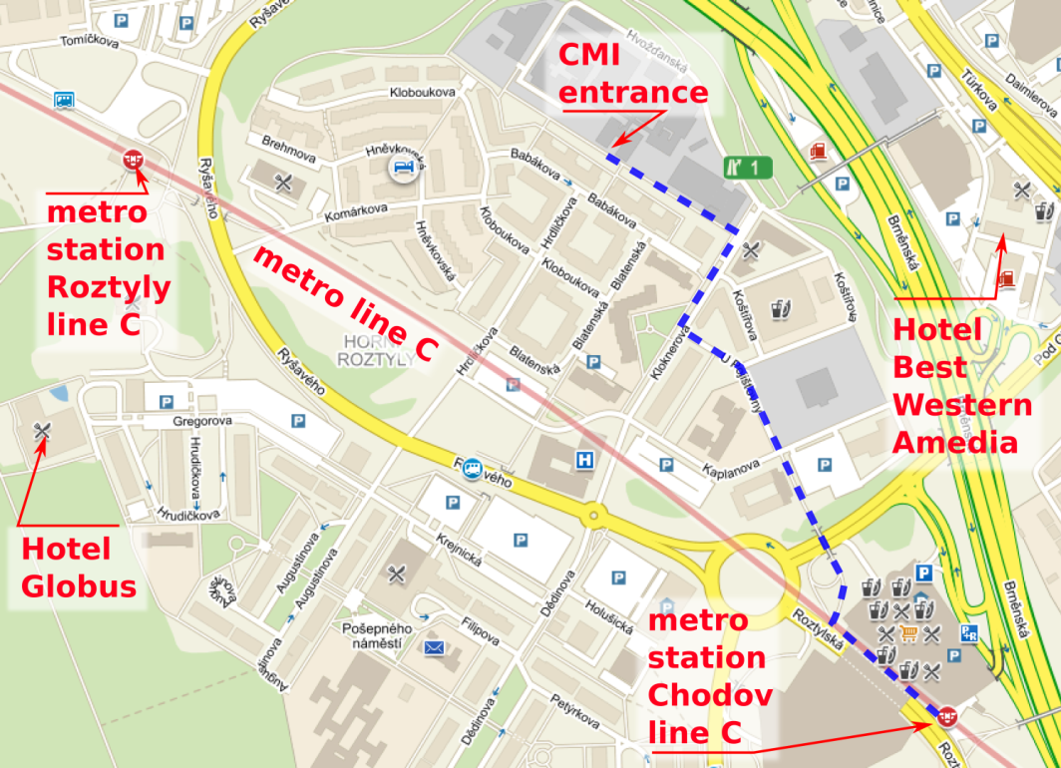

When you prefer to stay near CMI site, **Hotel Globus** or **BEST WESTERN Amedia Praha** are available.¨

# Accomodation

## Hotels near CMI site

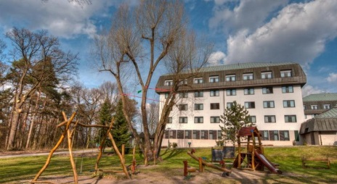**Hotel Globus**

Gregorova 2115/10, CZ - 148 00 Prague 4

Phone: +420-296 799 100; 296 799 504

Fax: +420-296 799 560

E-mail: rezervace@hotel-globus.cz

Web: <http://www.hotel-globus.cz/en/reservation/>

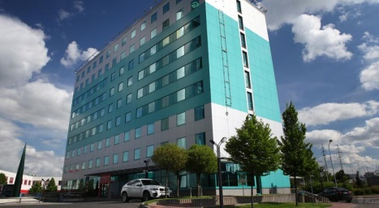

**AMEDIA Express Praha**

Turkova 5a/2318, Prague, 149 00, CZ   
Phone: +420 234623100  
Fax: +420 234623105

E-mail: prague@amediahotels.com

Web: <https://www.booking.com/hotel/cz/eurohotel-prag.html?aid=808251>

## Hotels between downtown and CMI

There are plenty of hotels in Prague downtown, you can check e.g. [booking.com](http://www.booking.com).

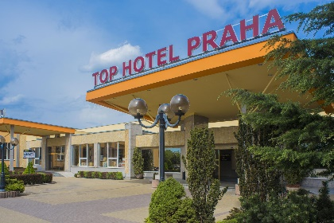**TOP HOTEL Praha**

Blažimská 1781/4, Prague, 149 00, CZ

Phone: +420 267284111

E-mail: sales@tophotel.cz

Web: <https://www.tophotel.cz/en/>

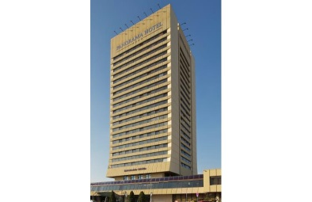**Panorama Hotel Prague**

Milevská 7, Prague, 14063

Phone: +420 261 161 111

E-mail: welcome@panoramahotelprague.com

Web: <http://www.panoramahotelprague.com>

# Travel info

## Currency

The official currency is Czech crown (CZK). 1 EUR ~ 24 CZK. In many supermarkets and restaurants in downtown, you can pay in EUR (with adverse rate, usually). Credit cards are applicable in most restaurants and in nearly any shop.

## Transportation

### Public transportation system

It is very common to use public transportation system. Only in rush-hours one can get delays up to 15 minutes on buses. Subway and trams are very precise. Googlemaps are very helpful in finding the right way.

Subway is operating from 5:00 am till 11:59 pm at least. Buses and trams operation time differs for each line. Few trams and buses are operating after midnight too.

Public transportation for 90 minutes costs 40 CZK. For 30 minutes about 30 CZK, 1 day (24 hours) 120 CZK, 3 days 330 CZK. You can swap lines anytime. You have to validate the ticket at first use in validator machine near entrance to the subway or inside bus/tram.

On bus stop at airport and at few places in downtown one can find ticket machine for credit cards. Otherwise, you have to buy tickets at cash machines in subway stations or at tobacco shops (cash/credit card). Cashless payment is possible by**cashless payment card only.** Terminals (validators) for the tickets are installed in **all trams** and in **the metro vestibules**.

More info or journey planner at <https://www.dpp.cz/en>

### Taxi

Official taxi from airport will get you anywhere in Prague for standard rate about 500 CZK (about 20 EUR). Rates per kilometre are from 25-36 CZK, boarding tax about 50 CZK, depending on taxi company. We recommend booking a taxi, because the price of hailing a taxi directly on the street is usually much higher.

24-hour taxi dispatching:

AAA radiotaxi, tel. +420 222 333 222; 14 014

City taxi, tel. +420 257 257 257

Modrý anděl, tel. +420 737 222 333

Another option is to arrange a taxi using the mobile application Liftago (<https://www.liftago.com>). The company works with professional drivers, many of whom also drive for traditional taxi dispatchers.

### Parking at Prague

Around Prague are P+R with good and fast connection to downtown. For parking check signs and parking machines. Details about parking zones are at <http://www.parkujvklidu.cz/prague-parking/> There are no EURO limits for driving car in downtown. At CMI Hvožďanská, there is free parking lot in front of gate or you can use few parking lots inside the CMI area.