Final Report – Draft B

Bilateral comparison
Of the turbine gas meter G1000

BILATERAL comparison

EURAMET Project No. 1007


Dr.Vahit Çiftçi – Hakan Kaykısızlı – Alper Elkatmış
(National Metrology Institute of Turkey)

Mijndert P. Van Der Beek - Rob Zwaan
(National Metrology Institute of Netherlands)

January 2010

Contents
- Introduction
- The instrument
- Calibration procedure
- Equipment and obtained results
  - Netherlands
  - Turkey
- Consistency of calibrations
  - Consistency of UME
- Bi-lateral Results
- Summary and conclusion of EUROMET 1007 bilateral comparison
- Comparison of EUROMET 862 and EUROMET 1007 measurement results
- Summary and conclusion of comparison between EUROMET 862 and EUROMET 1007 comparison results

- Introduction
The project EUROMET no.862 for the comparison of the axial turbine gas meter G650 concluded in October 2006. Each country performed the calibration of the turbine gas meter G650 with air in the barometric pressure. The range of flow rates was from 100 m³/h to 1000 m³/h. The participating laboratories used their usual calibration procedure. When the final draft of the comparison published, the results showed that something was wrong with the calibration of Turkey (UME).
Turkey (UME) wanted to investigate the reasons for this unexpected deviation form the mean of the other countries. Turkey’s (UME) gas measurement reference system was a combination of reference gas flow meters calibrated by the Netherlands (NMi), so a bilateral comparison was offered to check if something was wrong with the calibrations of UME reference standards. The aim of the bilateral comparison is to compare the performance of the calibrations of the gas meter in UME and NMI gas flow laboratories in order to investigate the need for a back-dated correction of UME reference K-factor according to the
results of Euromet project 862. An axial turbine gas meter G1000 was used as the decisive meter to compare low-pressure test facilities over the flow range (80 ÷ 1600) m³/h. It was decided to conduct this bilateral comparison during the Euramet Flow meeting held in Istanbul in 2007.
Table 1 – Time schedule
Country | Laboratory | Address of the  Place of calibration | Date of calibration | Responsible
Turkey  (ATA-CARNET) | TUBITAK – UME National Metrology Institute of Turkey | TUBITAK-UME  Anibal Cad. MAM Kampusu  PK54 - 41470 Gebze-Kocaeli / TURKEY | 01.4.-01.5.  2007 | Vahit  Ciftci
Netherlands | NMi VSL  Nederlands Meetinstituut Van Swinden Laboratorium | NMi VSL Flow  Thijsseweg 11, 2629JA Delft, The Netherlands | 01.6.-01.10. 2007 | Mijndert P. van der Beek
Turkey  (ATA-CARNET) | TUBITAK – UME National Metrology Institute of Turkey | TUBITAK-UME  Anibal Cad. MAM Kampusu  PK54 - 41470 Gebze-Kocaeli / TURKEY | 01.10.-01.12.  2007 | Vahit  Ciftci

- The instrument
The axial turbine gas meter (Fig. 1) was used for the comparison. The description of this meter is given below.
Manufacturer: VemmTec GERMANY
Type: G1000/DN200/200 | ANSI300/PN40 P_{max} : 60 bar
Size: G1000 | Inside diameter: DN 200
Serial number: 031271 | Pulse number HF1: 2743,08 imp/m³
Q_{min} : 80 m³/h | HF3 : 144,373 imp/m³
Weight: 100 kg | Q_{max} : 1600 m³/h

Figure 1 – Axial turbine gas meter, type IGTM

The dimensions of the meter are given in table 2 and in figure 2.

Table 2 - Dimensions of the meter
L | D | E | H | A | B | C
600 mm | 375 mm | 275 mm | 270 mm | 240 mm | 278 mm | 195 mm

Figure 2 - Dimensions of the meter

- Calibration procedure

- The turbine gas meter is tested in horizontal position by air.
- For the test it was necessary to use the upstream straightening pipe with a length of at least 5xDN.
- For the test it was necessary to use the downstream straightening pipe that is long with a length of at least 3xDN.
- The reference pressure from the turbine gas meter was measured from the output “p_{r}”.
- The reference temperature from the turbine gas meter was measured at the distance 2 x DN downstream of the turbine gas meter.
- For the test it was necessary to use both pulse outputs of the test meter, HF1 and HF3.
- The test should be performed in a laboratory where the temperature is from 19.5°C to 23.5°C. The upstream pressure of the meter should be near atmospheric pressure.
- The oil pump of the turbine gas meter is not to be used.
- Before the beginning of the test, the gas meter worked 20 minutes at nominal flow rate Q=800 m³/h.
- The turbine gas meter was tested at 6 flow rates: 1600 m³/h, 1100 m³/h, 650 m³/h, 400 m³/h, 160 m³/h and 80 m³/h.
- The test at one flow rate should be repeated at least 3 times and then the means of values in the table 3 and table 4 have to be calculated. The flow rate has to be in the interval ± 3% of the required value.
- A single test in one flow rate has to take more then 1 minute. Beforehand, the flow rate has to be accurately stabilised.
- Each participant recorded the results in the form of table 3 given below for HF1 and HF3 output results of the test meter (decisive meter).
UME will use the G1000 type master meter (serial number 031265) for calibrating the test meter. This master meter has two HF pulse outputs; 145,259 and 2759,92 imp/m³ respectively. UME will use both outputs of the master meter for this bilateral comparison. Because the K-factor of this master meter was a point of discussion in Euromet 862 project, analysis of the results of new NMI certificate for the master meter will also be mentioned in the final report. So in the new NMI certificate, results of both HF pulse outputs of the meter with serial number 031265 were given to investigate the problem with the UME results for Euromet 862.

Table 3 - Required table of results
Table3
Test Flow rates | Reference standard, flow rate at working Condition | Test meter flow rate at working Condition by HF1 | Absolute pressure in the meter | Temperature in the meter | Reference standard, flow rate at Standard Condition | Test meter flow rate at Standard Condition by HF1 | Error for the Standard Conditions for HF1 | Uncertainty of the error  U (k=2)
(m³/h) | (m³/h) | (m³/h) | (Pa) | (°C) | (Sm³/h) | (Sm³/h) | (%) | (%)
1600
1100
650
400
160
80

Table 3 - Required table of results
Table4
Test Flow rates | Reference standard, flow rate at working Condition | Test meter flow rate at working Condition by HF1 | Absolute pressure in the meter | Temperature in the meter | Reference standard, flow rate at Standard Condition | Test meter flow rate at Standard Condition by HF1 | Error for the Standard Conditions for HF1 | Uncertainty of the error  U (k=2)
(m³/h) | (m³/h) | (m³/h) | (Pa) | (°C) | (Sm³/h) | (Sm³/h) | (%) | (%)
1600
1100
650
400
160
80

Error of the meter is value which shows the relationship in percentage terms of the difference between the volume indicated by the meter and the volume which has actually flowed through the meter, to the later value.

$E=\frac{V_{i}−V_{c}}{V_{c}}\text{.}\text{100}$ (%) [1]
Where E is the error of the meter
V_{i} is the indicated volume by the meter (m³)
V_{c} is the real volume which has actually flowed through the meter (m³)

Error of the meter is value which shows the relationship in percentage terms of the difference between the volume indicated by the meter and the volume which has actually flowed through the meter, to the later value.

$E=\frac{V_{i}−V_{c}}{V_{c}}\text{.}\text{100}$ (%) [1]
Where E is the error of the meter
V_{i} is the indicated volume by the meter (m³)
V_{c} is the real volume which has actually flowed through the meter (m³)

- Equipment and obtained results
  - Netherlands
The turbine meter used for this bilateral comparison has been calibrated on the ‘Big Installation’ of NMi VSL, located in our lab in Delft, Thijsseweg 11.The installation is made up of two axial blowers, one for low flow rates (up to 4000 m3/h) and one for high flow rates (up to 15000 m3/h), a regulated heat exchanger after the blowers, data acquisition system, piping, pressure and temperature sensors and five reference meters. The reference meters are described in table 4: Nmi Gas Flow rate Measurement system’s total uncertainty is about 0.15 % (for k=2) at this range.

Table 4: Reference meters in big installation in NMi
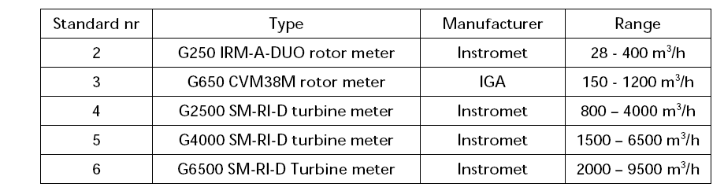

Results of Netherlands for UME Transfer meter with serial number 031271:
Table5
Test Flow rates | Reference flowrate  [m³/h] | Indicated flow rate  [m³/h] | Pabs MUT  [Pa] | Tabs MUT  [°C] | Reference flowrate  @  Standard Conditions  [sm³/h] | Indicated flow rate  @  Standard Conditions  [sm³/h] | Error HF1  [%] | Uncertainty  [%]
1600 | 1605,0 | 1603,1 | *** | *** | *** | *** | -0,12 | 0,19
1100 | 1103,0 | 1102,0 | *** | *** | *** | *** | -0,09 | 0,19
650 | 645,3 | 644,0 | *** | *** | *** | *** | -0,20 | 0,19
400 | 394,9 | 394,0 | *** | *** | *** | *** | -0,22 | 0,19
160 | 158,1 | 157,0 | *** | *** | *** | *** | -0,68 | 0,20
80 | 78,9 | 77,3 | *** | *** | *** | *** | -2,09 | 0,20

  - Turkey

UME - Medium Flow Gas Measurement System Description
As seen from figure 13, UME Medium Gas Flow Rate Measurement System was designed to operate in the range of 5-4800 m³/h for gas flow meter calibrations. It consists of one flow computer, two suction fans with frequency controller, five reference flow meters with a different measuring capacity and upstream and downstream of each flow meter has pressure-actuated ball valves. Time measurement, pulse counts, temperature and pressure at upstream of each flow meters are recorded by the UME flow computer.
Flow meters are traceable to NMi and UME. UME Medium Gas Flow rate Measurement system’s total uncertainty is about 0.18 % (for k=2).

Figure 13 – Test bench in UME
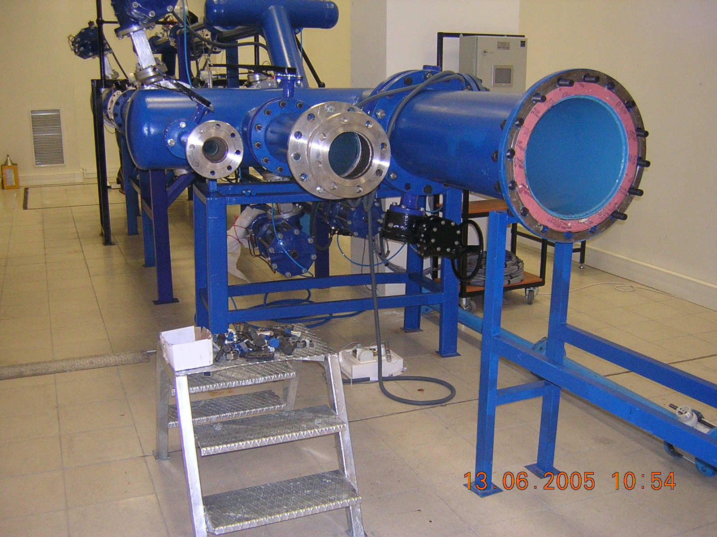
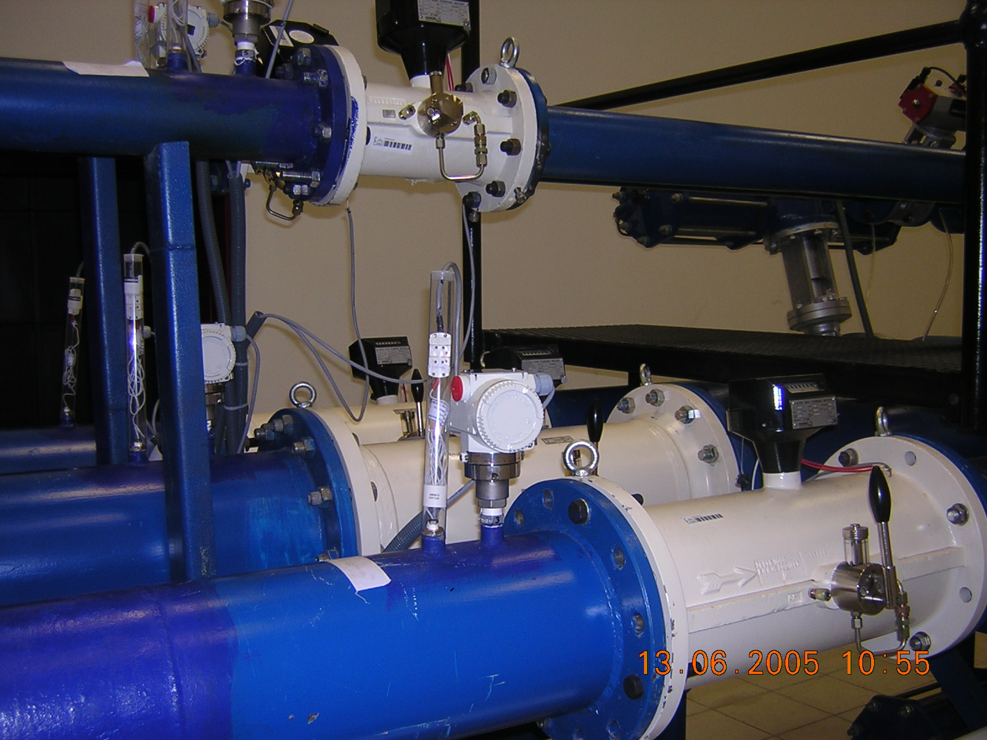

Date: 30.04.2007, First Comparison result for TS- 031271

Each period for each measurement, data was taken from the output signals of Transfer Standard’s HF1 and HF3 channels and results were recorded; it has been seen from the results that there was no significant difference between two signals data.
Table 7
Test Flow rates | Reference standard, flow rate at working Condition | Test meter flow rate at working Condition by HF1 | Absolute pressure in the meter | Temperature in the meter | Reference standard, flow rate at Standard Condition | Test meter flow rate at Standard Condition by HF1 | Error for the Standard Conditions for HF1 | Uncertainty of the error  U (k=2)
(m³/h) | (m³/h) | (m³/h) | (Pa) | (°C) | (Sm³/h) | (Sm³/h) | (%) | (%)
80 | 81,298 | 78,162 | 995,63 | 20,00 | 79,861 | 76,803 | -3,830 | 0,20
160 | 161,651 | 159,214 | 995,60 | 20,17 | 158,671 | 156,350 | -1,463 | 0,20
400 | 403,349 | 401,268 | 995,42 | 20,33 | 395,427 | 393,763 | -0,421 | 0,20
650 | 653,611 | 650,433 | 995,27 | 20,41 | 639,857 | 637,999 | -0,290 | 0,20
1100 | 1102,637 | 1095,025 | 994,71 | 20,14 | 1076,973 | 1074,476 | -0,232 | 0,20
1600 | 1592,771 | 1575,480 | 993,79 | 20,41 | 1545,272 | 1543,064 | -0,143 | 0,20
Date: 30.11.2007, Second Comparison result for TS-031271
Table 8
Test Flow rates | Reference standard, flow rate at working Condition | Test meter flow rate at working Condition by HF1 | Absolute pressure in the meter | Temperature in the meter | Reference standard, flow rate at Standard Condition | Test meter flow rate at Standard Condition by HF1 | Error for the Standard Conditions for HF1 | Uncertainty of the error  U (k=2)
(m³/h) | (m³/h)4 | (m³/h) | (Pa) | (°C) | (Sm³/h)5 | (Sm³/h) | (%) | (%)
80 | 85,350 | 83,873 | 1002,57 | 20,70 | 84,2305 | 82,791 | -1,709 | 0,20
160 | 157,850 | 156,672 | 1002,68 | 21,38 | 155,4326 | 154,314 | -0,720 | 0,20
400 | 412,045 | 410,891 | 1000,37 | 20,26 | 405,8387 | 405,312 | -0,130 | 0,20
650 | 653,818 | 651,915 | 999,09 | 20,42 | 642,6812 | 641,878 | -0,125 | 0,20
1100 | 1097,066 | 1091,237 | 996,05 | 20,89 | 1070,6148 | 1069,452 | -0,109 | 0,20
1600 | 1588,486 | 1572,787 | 994,38 | 18,11 | 1556,1313 | 1553,512 | -0,168 | 0,20

- Consistency of the calibrations
5.1 Consistency of UME
During the project, the turbine gas meter with serial number 031271 was tested two times in the pilot laboratory (UME). Obtained results are mentioned below.
Table 9
flow rate (m³/h) | error of the meter 30.4.2007 | error of the meter 30.11.2007 | difference
(m³/h) | (%) | (%) | (%)
80 | -3,830 | -1,709 | 2,121
160 | -1,463 | -0,720 | 0,743
400 | -0,421 | -0,130 | 0,291
650 | -0,290 | -0,125 | 0,165
1100 | -0,232 | -0,109 | 0,123
1600 | -0,143 | -0,168 | 0,025

Graph 1
- Bi-lateral Results
Transfer Standard (TS) with serial number 031271 was calibrated by two laboratories and the results are presented in the Table 10 and Graph 2.
Table 10
flow rate (m³/h) | NMi  error of the meter 01.06.2007 | UME  error of the meter 30.04.2007 | UME  error of the meter 30.11.2007 | Maximum error difference between NMi and UME first results | Maximum error difference between NMi and UME second results
(m³/h) | (%) | (%) | (%) | (%) | (%)
80 | -2,09 | -3,830 | -1,709 | 1,74 | -0,381
160 | -0,68 | -1,463 | -0,720 | 0,783 | 0,04
400 | -0,22 | -0,421 | -0,130 | 0,201 | -0,09
650 | -0,20 | -0,290 | -0,125 | 0,09 | -0,075
1100 | -0,09 | -0,232 | -0,109 | 0,142 | 0,019
1600 | -0,12 | -0,143 | -0,168 | 0,023 | 0,048

Graph 2

Evaluation of degree of equivalence coefficient of bilateral comparison “Ei”
To evaluate the degree of eguivalence cofficient “Ei” for bilateral comparison, special methoad of M.G.Cox3 has been applied and the comparison equation is stated below.
$$E_{i}=\frac{X_{\text{lab}}−X_{\text{ref}}}{\sqrt{U_{\text{lab}}^{2}+U_{\text{ref}}^{2}}}$$
X_{ref}: Pilot country’s measurement error values (%)
X_{lab}: Other country’s measurement error values (%)
U_{ref}: Pilot country’s measurement uncertainities
U_{lab}: Other country’s measurement uncertainities
⎮E_{i}⎮≤ 1 Pass
⎮E_{i}⎮> 1 Fail

Table 11 - Bilateral Comparison result table for the First measurement

Nominal Flowrate | NMi  X_{ref} | UME  X_{lab} | NMi  U_{ref} | UME  U_{lab} | E_{i} | Result
(m3/h) | - | - | - | - | - | -
80 | -2,09 | -3,83 | 0,19 | 0,20 | -6,31 | fail
160 | -0,68 | -1,46 | 0,19 | 0,20 | -2,84 | fail
400 | -0,22 | -0,42 | 0,19 | 0,20 | -0,73 | pass
650 | -0,2 | -0,29 | 0,19 | 0,20 | -0,33 | pass
1100 | -0,09 | -0,23 | 0,20 | 0,20 | -0,50 | pass
1600 | -0,12 | -0,14 | 0,20 | 0,20 | -0,08 | pass

Table 12 - Bilateral Comparison result table for the First measurement

Nominal Flowrate | NMi  X_{ref} | UME  X_{lab} | NMi  U_{ref} | UME  U_{lab} | E_{i} | Result
(m3/h) | - | - | - | - | - | -
80 | -2,09 | -1,71 | 0,19 | 0,20 | 1,38 | pass
160 | -0,68 | -0,72 | 0,19 | 0,20 | -0,14 | pass
400 | -0,22 | -0,13 | 0,19 | 0,20 | 0,33 | pass
650 | -0,2 | -0,13 | 0,19 | 0,20 | 0,27 | pass
1100 | -0,09 | -0,11 | 0,20 | 0,20 | -0,07 | pass
1600 | -0,12 | -0,17 | 0,20 | 0,20 | -0,17 | pass

From the Table 11 and Table 12, the degree of equivalence coefficient of bilateral comparison “Ei” show that both comparisons are reasonable acceptable

- Summary and conclusion of EUROMET 1007 bilateral comparison
It has been seen that the bilateral comparison results are satisfactory for Turkey (UME) for the flow rates of 1600 m³/h, 1100 m³/h, 650 m³/h, 400 m³/h and 160 m³/h.
High error difference can be seen for the minimum measurement rate, 80 m³/h, between two measurements of UME. The frequency converter may be the reason for inconsistency at low flow rates.

- Comparison of EUROMET 862 and EUROMET 1007 measurement results
  - NMI - UME comparison for EUROMET 862
Table 13 was obtained from EUROMET 862 Final report Draft –A

Table 13
flow rate (m³/h) | NMi  error of the meter EUROMET 862 | UME  error of the meter EUROMET 862 | Maximum error difference between NMi and UME for EUROMET 862
(m³/h) | (%) | (%) | (%)
100 | 1,18 | 0,96 | 0,22
200 | 0,45 | 0,73 | -0,28
300 | 0,26 | 0,45 | -0,19
400 | 0,32 | 0,62 | -0,3
500 | 0,37 | 0,68 | -0,31
650 | 0,46 | 0,72 | -0,26
801 | 0,43 | 0,68 | -0,25
1000 | 0,26 | 0,58 | -0,32

  - NMI - UME Eror difference comparison for EUROMET 862 and EUROMET 1007
From the Table 10 and Table 11, Table 13 and Graph 3 can be obtained.
Table 12
flow rate (m³/h) | Error differences between NMi and UME For EUROMET 862 | Error differences between NMi and UME For EUROMET 1007
(m³/h) | (%) | (%)
80 | 0,220 | -0,381
160 | -0,280 | 0,040
400 | -0,300 | -0,090
650 | -0,260 | -0,075
1100 | -0,320 | 0,019
1600 | - | 0,048

Graph 3
  - NMI consistency
The gas meter calibration results consistency for UME Master meter 031265 calibrated in 2004 and 2007; Table 13 and Graph 4 shows the consistency of both measurements.
Table 13
flow rate (m³/h) | error of the meter 27.4.2004 | error of the meter 30.11.2007 | difference
(m³/h) | (%) | (%) | (%)
80 | -0,28 | -0,50 | 0,22
160 | -0,04 | -0,12 | 0,08
400 | -0,18 | -0,17 | -0,01
650 | -0,20 | -0,19 | -0,01
1100 | -0,13 | -0,09 | -0,04
1600 | -0,12 | -0,07 | -0,05

Graph 4
Graph 2

  - UME Installation effects Investigation and consistency
Table 14
flow rate | Error  Between UME reference standard and UME-TS (Reference standard was connected with TS in serial)  EURMET 1007  30.11.2007 | Error  Between UME reference standard and UME-TS (Reference standard was put on place)  EURMET 1007  30.11.2007 | Error  Between NMi reference standard and UME-TS  EURMET 1007  01.06.2007
(m³/h) | (%) | (%) | (%)
80 | -1,875 | -1,709 | -2,09
160 | -0,772 | -0,72 | -0,68
400 | -0,138 | -0,13 | -0,22
650 | -0,108 | -0,125 | -0,20
1100 | -0,072 | -0,109 | -0,09
1600 | -0,123 | -0,168 | -0,12

Graph 5

- Summary and conclusion of comparison between EUROMET 862 and EUROMET 1007 comparison results:
It can be seen from the Comparison Graph 3 “COMPARISON OF EUROMET 862 and EUROMET 1007”, there is are big differences (about 0,2%, 0,3%) between two comparisons.
Those differences might be related with;
- Master meter “K” factor
To investigate the UME master meter “K” factor, we sent the UME master meter to NMi for re-calibration, at the same time with the Transfer Standard for bi-lateral comparison.
The UME master meter 031265 calibrations at NMI for the second time showed that the results of two calibrations by NMI in 2004 and 2007 are consistent (Table 13 and Graph 4). And Graph 4 shows that there is no need for correction of UME reference K-factor used on the results of Euromet project 862.
- UME overall system performance, during the EUROMET 862 inter-comparison.
- Investigation of UME Medium Flow standards’ Installation affects; Installation effects of UME Piping system were investigated during the Second tour measurement of EUROMET 1007 at UME. First, UME reference meter and UME TS was connected in serial and data was taken, then UME reference meter was put on place than data was taken. And than Error and repeatability analyses were done. As seen from Table 14 and Graph 5, there is no reasonable difference between them. This means that UME Installation effects of piping system did not affect the EUROMET project 862.
- Investigation of Flow computer: The same flow computer was used for EUROMET 862 and EUROMET 1007 comparison measurements without any changes.
- Investigation of measurants: Measurements were carried out by the same researchers in both comparisons.
- Air conditioning unites: There were some problems with the air conditioning unit during the measurements of EUROMET 862 inter comparison. But this may not be so important if the temperature, pressure and humidity sensors are working correctly.
- Investigation of Temperature and pressure sensors: After EUROMET 862 intercomparison measurements, we realised that from time to time those sensors do not work properly. Sometimes they give, sometimes wrong signals because of some noise problems due to the high magnetic field induced by suction fans. Therefore they are always under our control with the other calibrated reference standards. We have ordered new sensors to replace the existing sensors.

m³/h: Flowrate at working conditions
Sm³/h: Flowrate at standard conditions, 20 ⁰C and 1013,25 mbar
m³/h: Flowrate at working conditions
Sm³/h: Flowrate at standard conditions, 20 ⁰C and 1013,25 mbar
m³/h: Flowrate at working conditions
Sm³/h: Flowrate at standard conditions, 20 ⁰C and 1013,25 mbar
3) Cox M.G., Metrologia, 2002, 39, 589-595

